EXPERIMENT 7
PROBLEM :
Implement a sliding window protocol with piggybacking for efficient data transmission and error control. Simulate data transfer between two nodes and visualize the window movements and acknowledgments using cisco packet tracer.
AIM: Implementation of sliding window protocol with piggybacking
PROCEDURE:
PHASE 1: Setup the Network Environment
Step 1: Open cisco packet tracer
1. Launch cisco packet tracer
Step 2: Add two PCs and one switch
Step 3: Connect the PCs
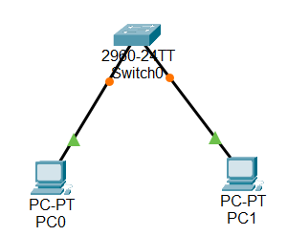
PHASE 2: Configure IP Addresses
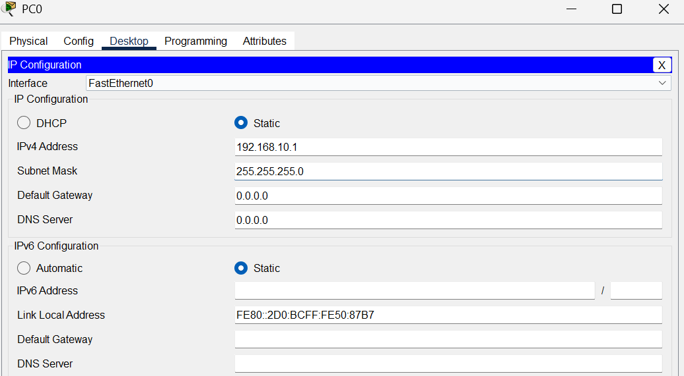
PHASE 3: SLIDING WINDOW PROTOCOL
. Used for Flow Control and Error Control
. Sender can send multiple frames before waiting for acknowledgment
. Window Size controls number of unacknowledgment frames allowed at a time
. Improves network efficiency and throughput
Step 4: PIGGYBACKING
. Acknowledgments are attached /included inside outgoing DATA frames
. Avoids sending separate ACK packets
. Saves bandwidth and improves efficiency
. PC1 send ACK inside its own data frames back to PC0

PHASE 4: Test Connectivity
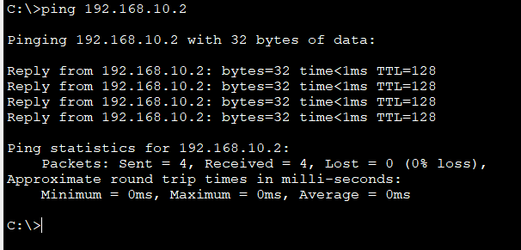
PHASE 5: SIMULATE SLIDING WINDOW WITH PIGGYBACKING
Step 5: Switch to simulation mode
1. In the simulation panel , click “Edit Filters”
2. Uncheck everything except:
. ICMP
. TCP (if available)
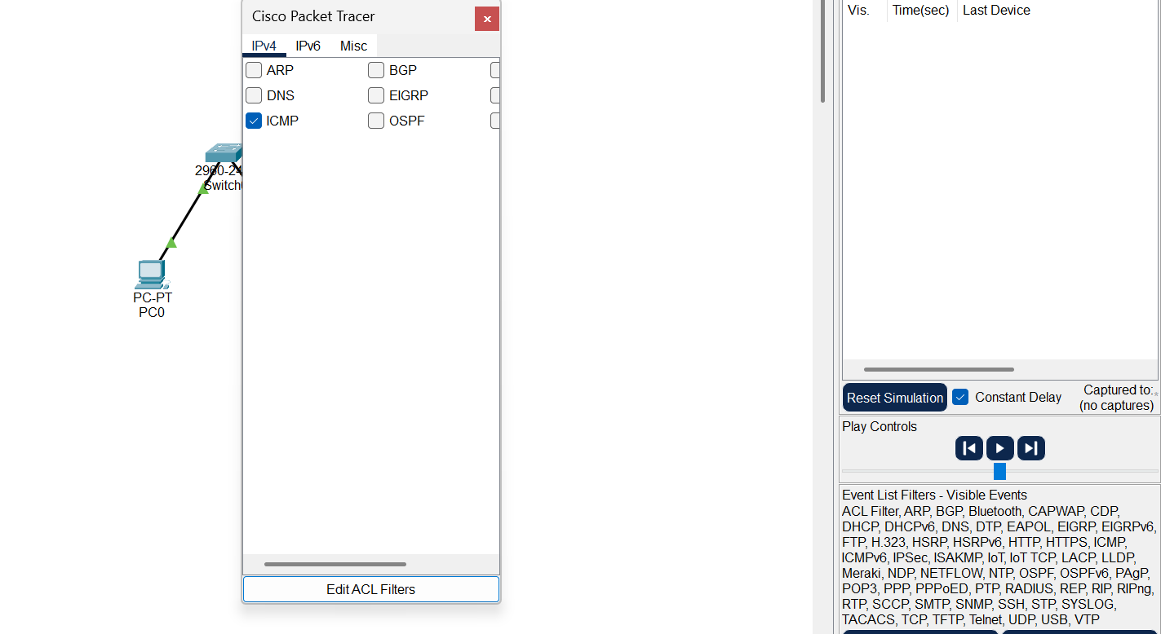

Step 6: ADD Simple PDU (Data frame PC0- PC1)
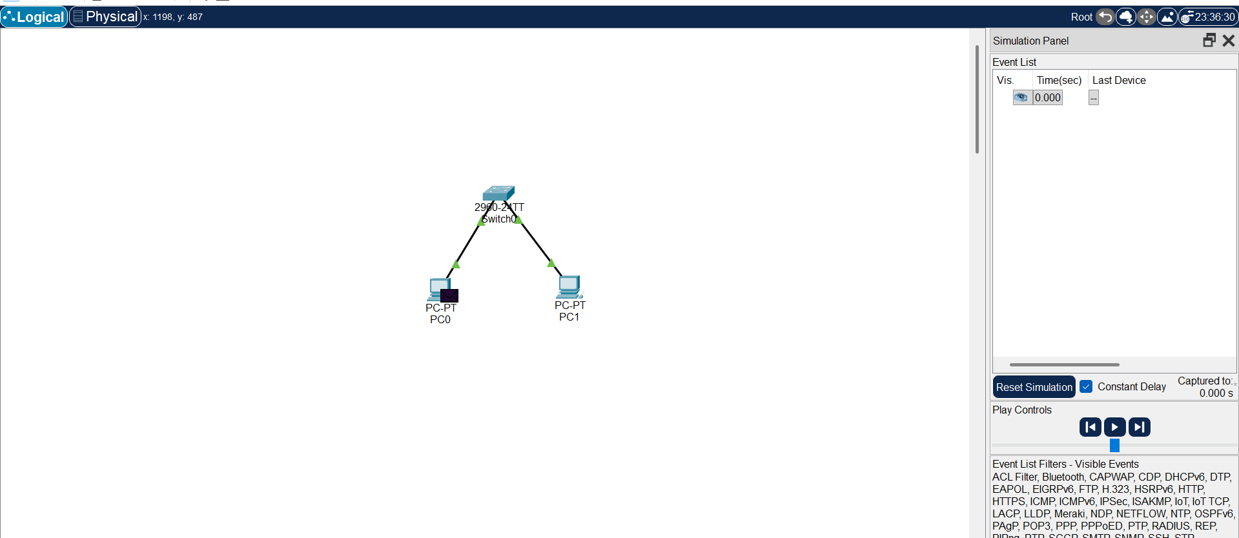
Step 7: Add Return PDU (Piggybacked ACK – PC1- PC0)
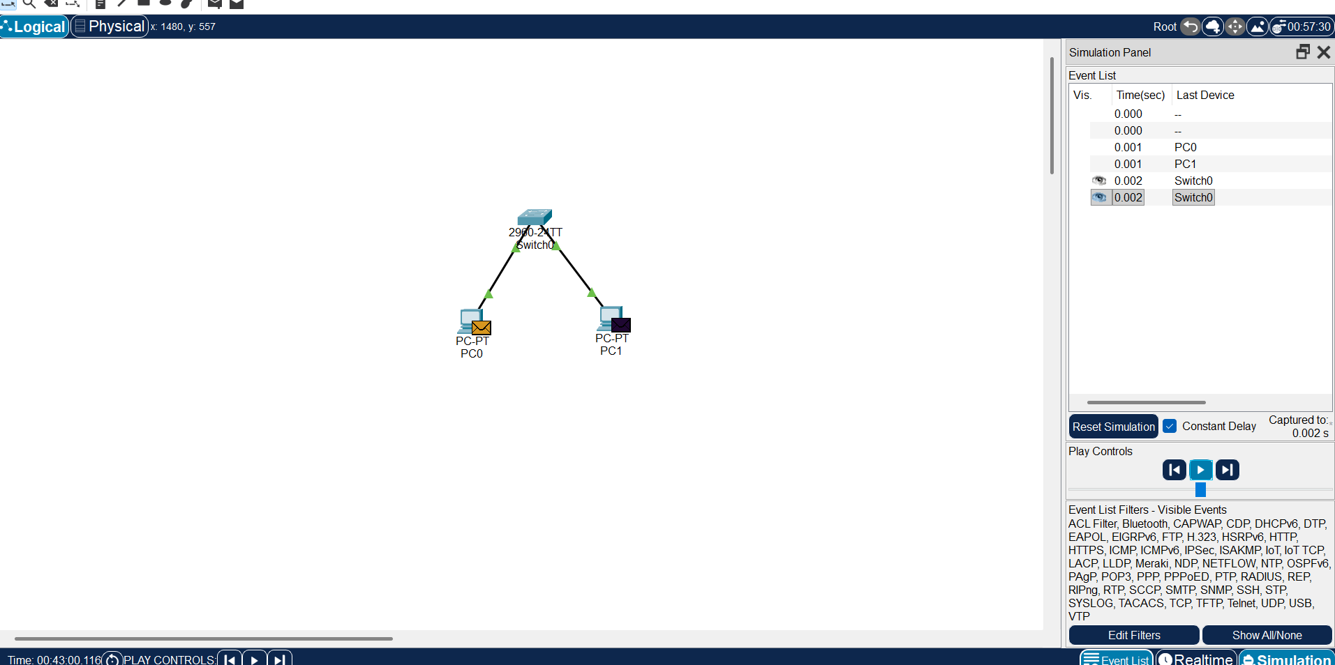
Step 8: Observe Piggybacked Acknowledgments
1. Watch the return packet frm PC1 TO PC0
2. This packet carries both data and acknowledgments together
3. This is the piggybacking in action – no separate ACK packet needed.

